**Introduction:**

Created a Web application which gives nutrition data based on the search item.

**Team members:**

1. Bhavya Sri Sirasanagandla

Contribution: 50%

1. Manideep Nadimpelli

Contribution: 50%

**Objective:**

Create a web application using HTML, CSS, Angular and Bootstrap.

1.Created Login ,Registration ,Home pages using localstorage.

2.Used Nutritionix and text to speech converter APIs.

**Features:**

* User can register using register page. Added form validations and alert messages.
* User can login once he/she enters the valid details.If not error messages were shown.
* User can see the calories and weight for the food searched.
* Text to speech API will readout the searched item name once the user clicks search button.

**Implementation:**

1. Created an angular project in WebStorm IDE. By default, “app” component will be created. Also created 3 components home, register, login.

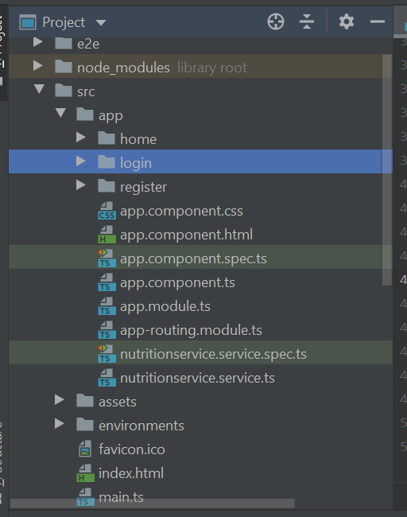

1. Created input tags and added form validations with corresponding messages.

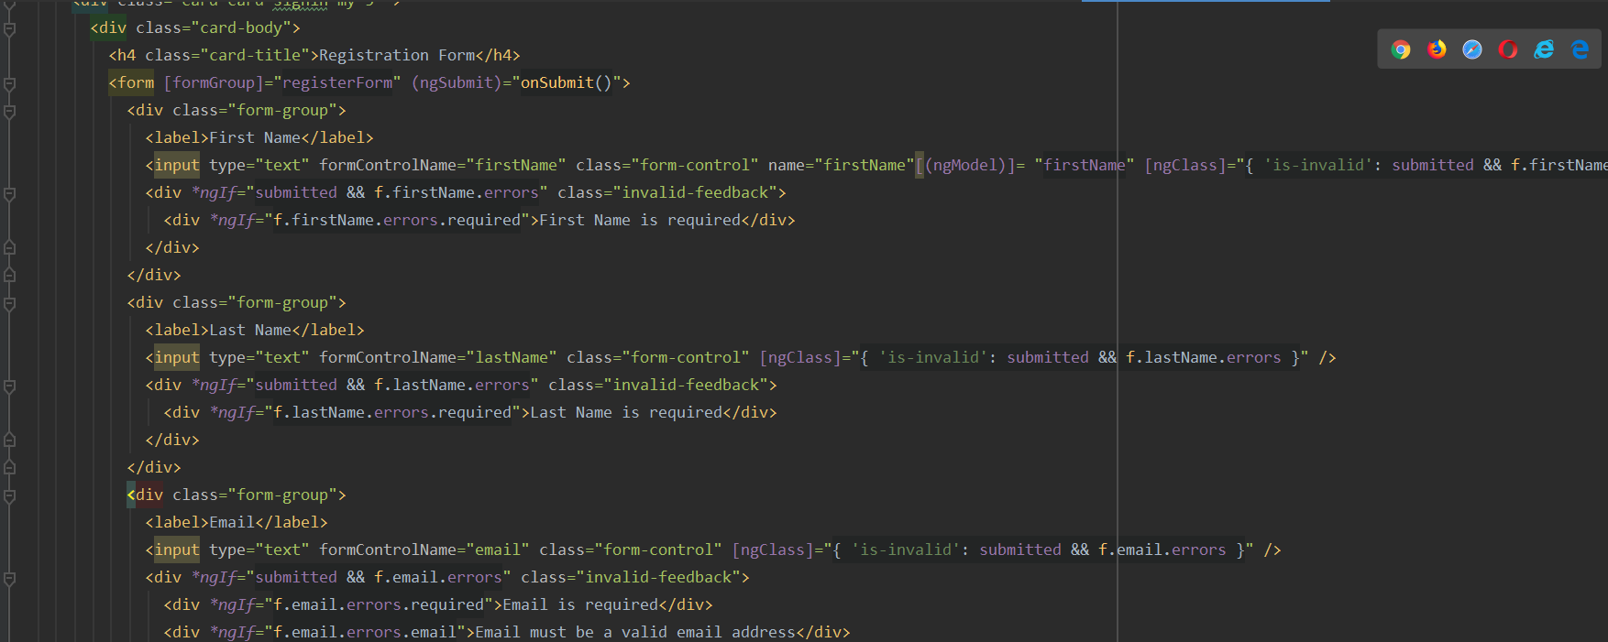

1. Used local storage to store the user details.

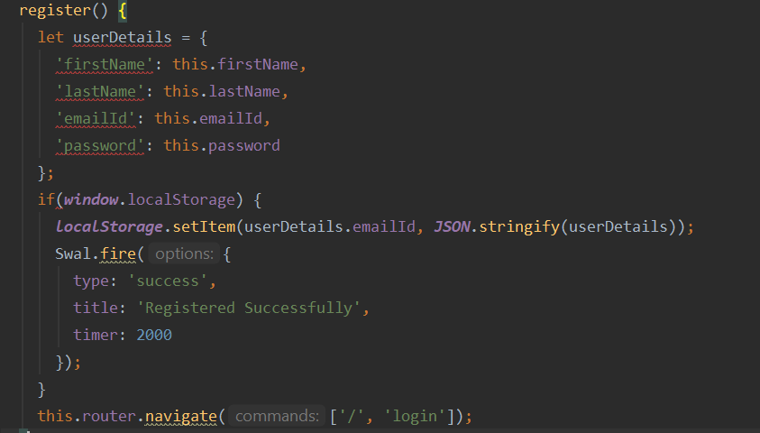

1. Used the same local storage to retrieve the user data while logging.If the credentials are wrong we are displaying an alert message(used sweet alert 2).

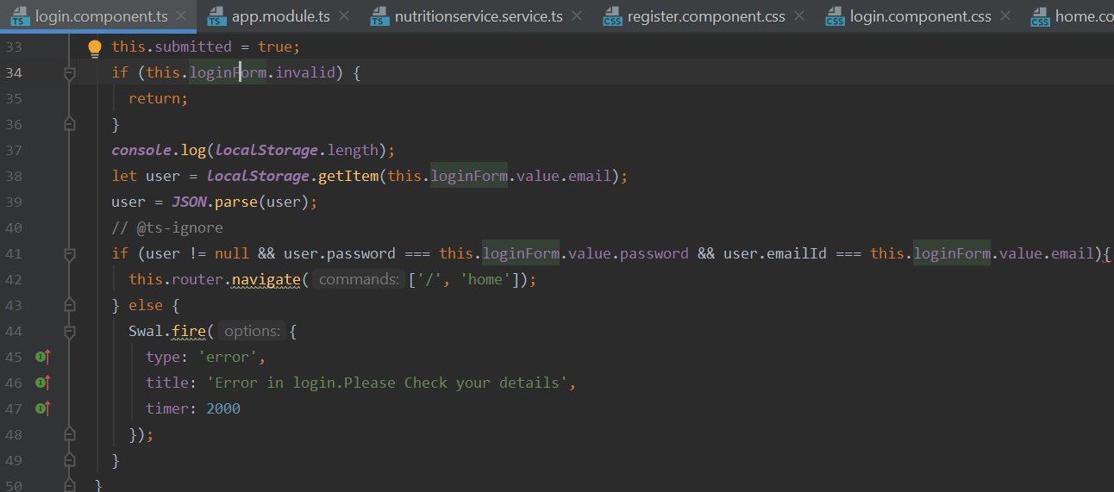

1. Used nutritionIx API to get the nutrition data. For that we created a service and did a http get call.

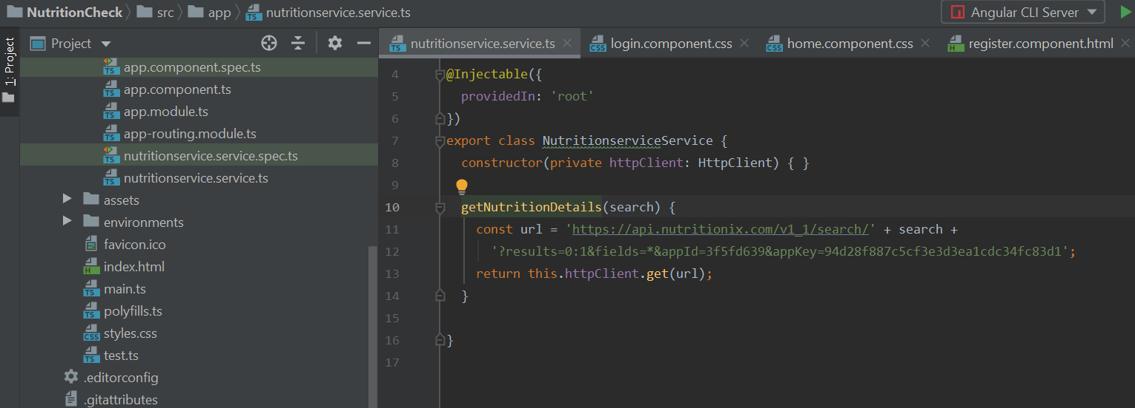

1. Used responsiveVoice API to convert the text searched to speech.Created keys in <https://responsivevoice.org/api/> .

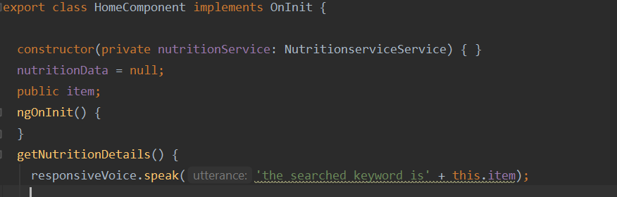

1. Implemented Routing using AppRoutingModule.

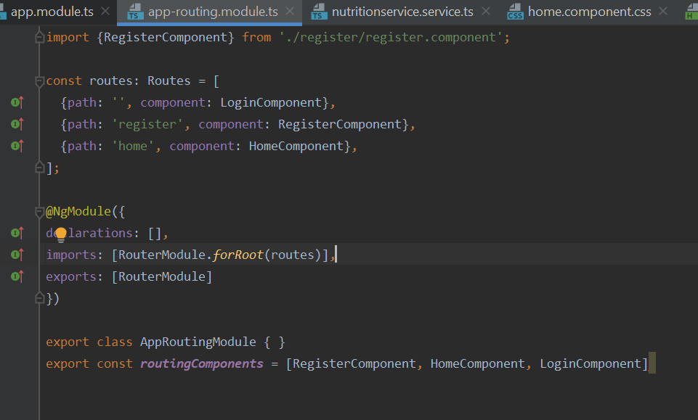

**Design:**

1. By default login page will be shown to the user.

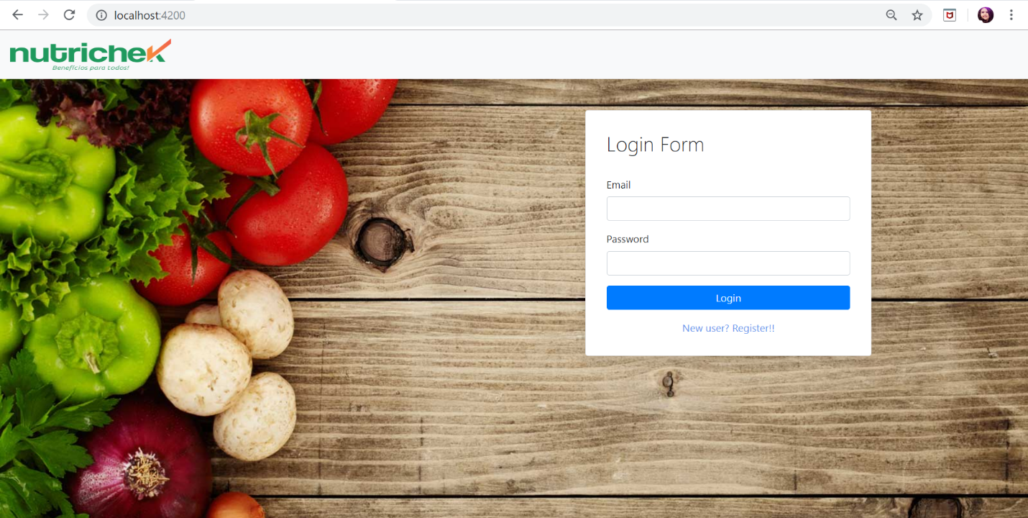

1. If the user doesn’t have any account he can register using register link which will navigate to the registration page.

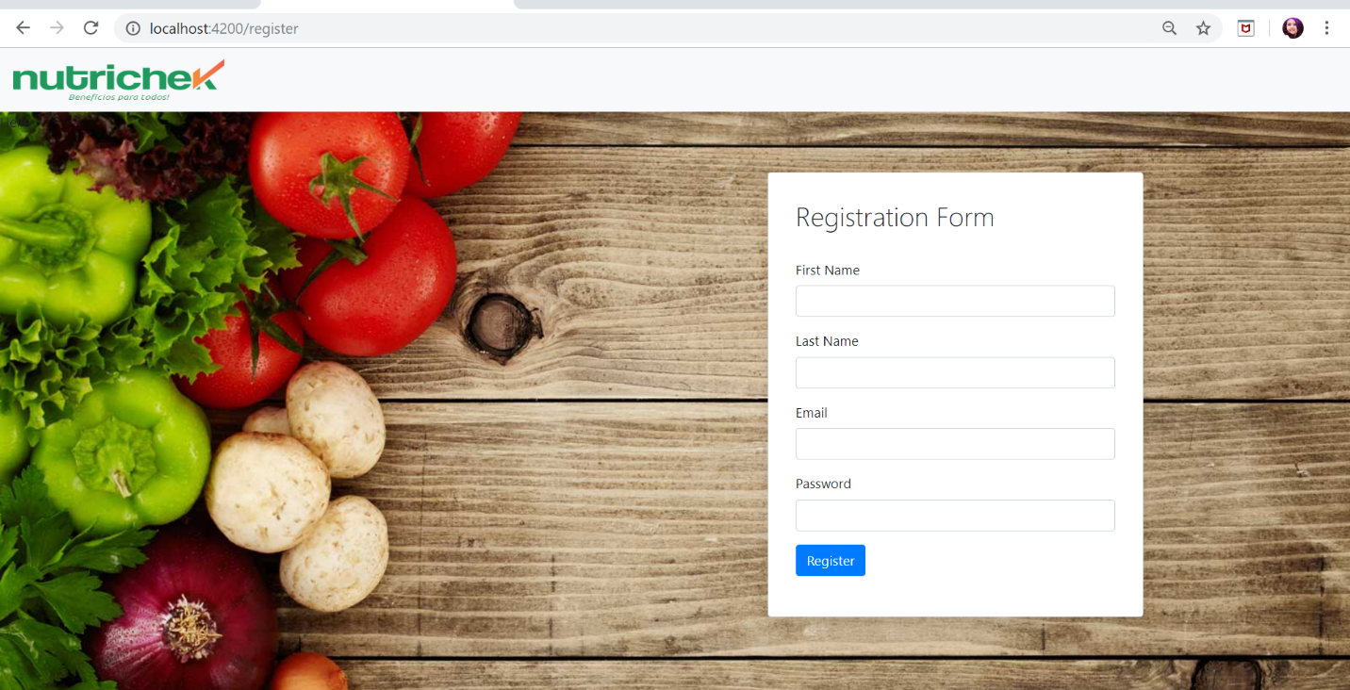

1. Added form validation to display errors.

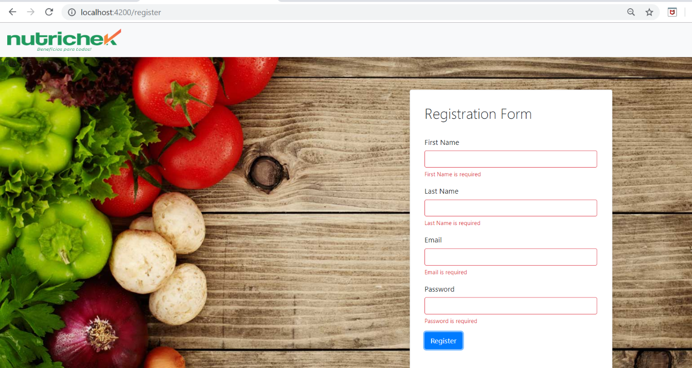

1. Added success message using sweet alert.

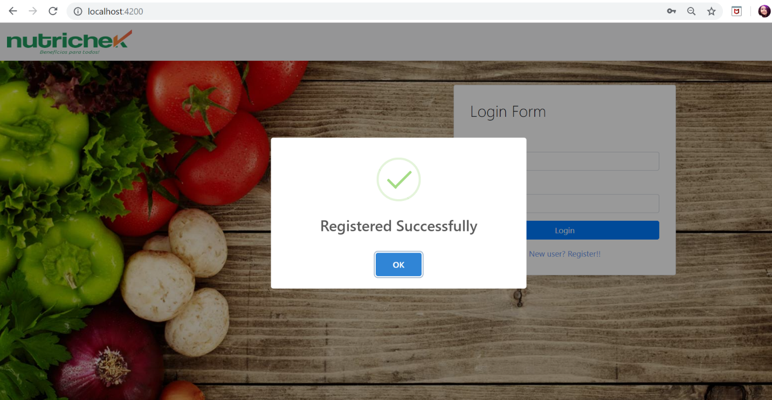

1. Used local storage to store the user data.

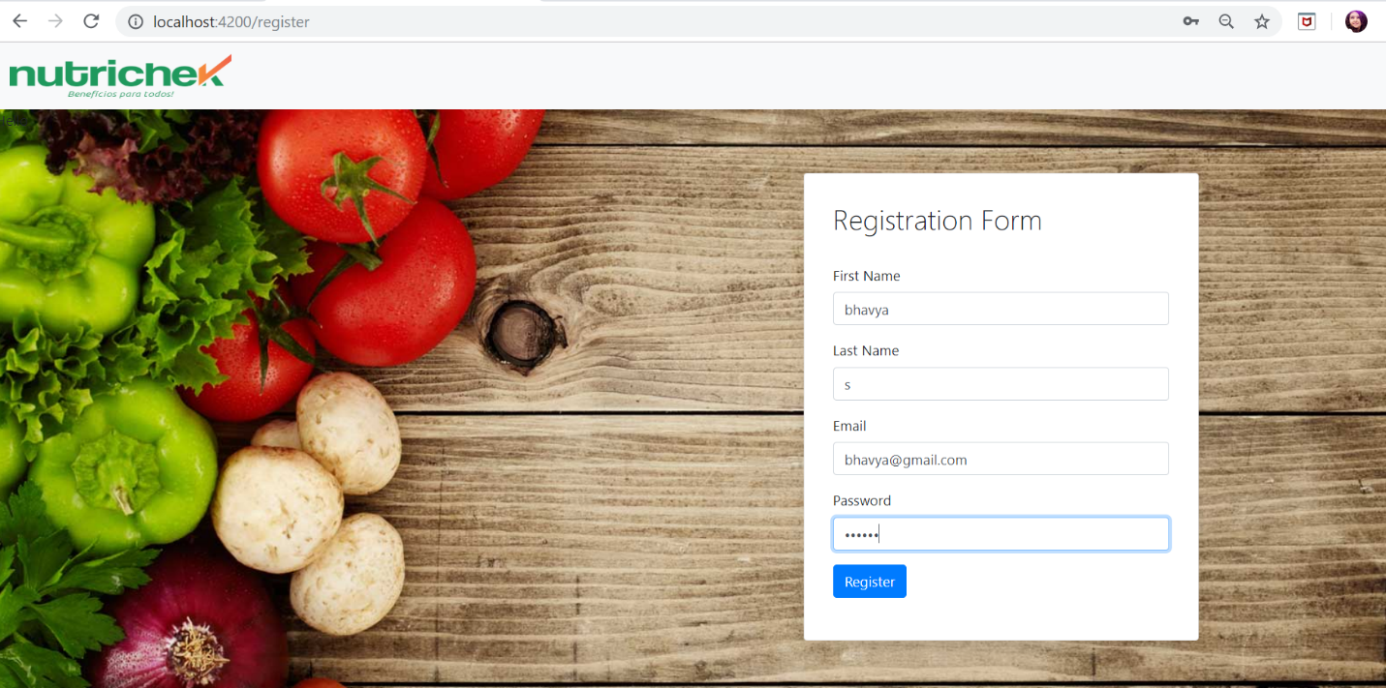

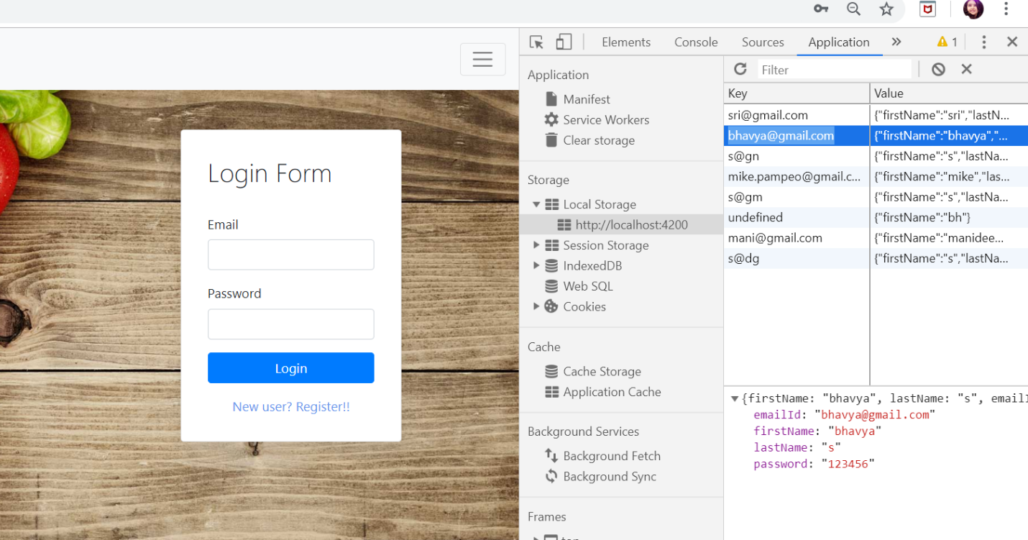

1. Once the user logins with home page is shown. If not displayed error messages.

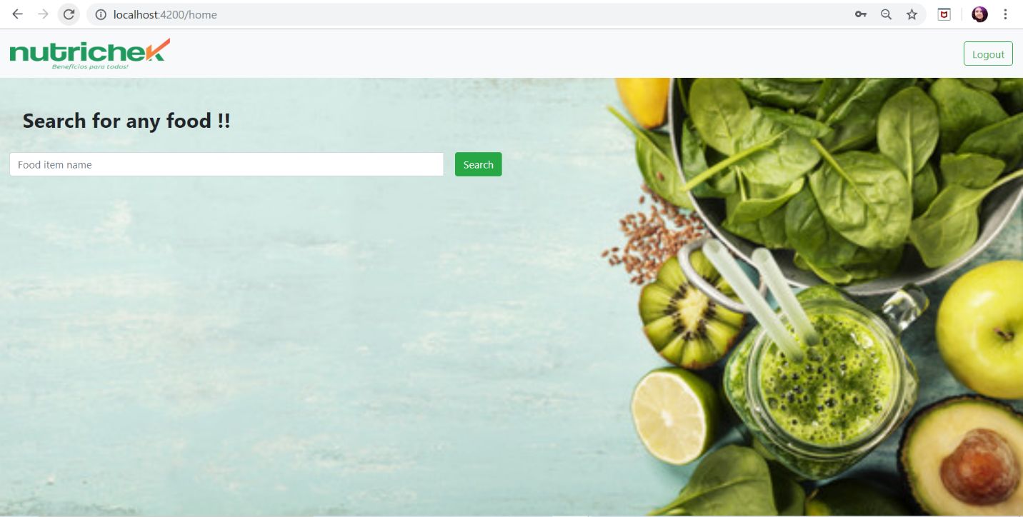

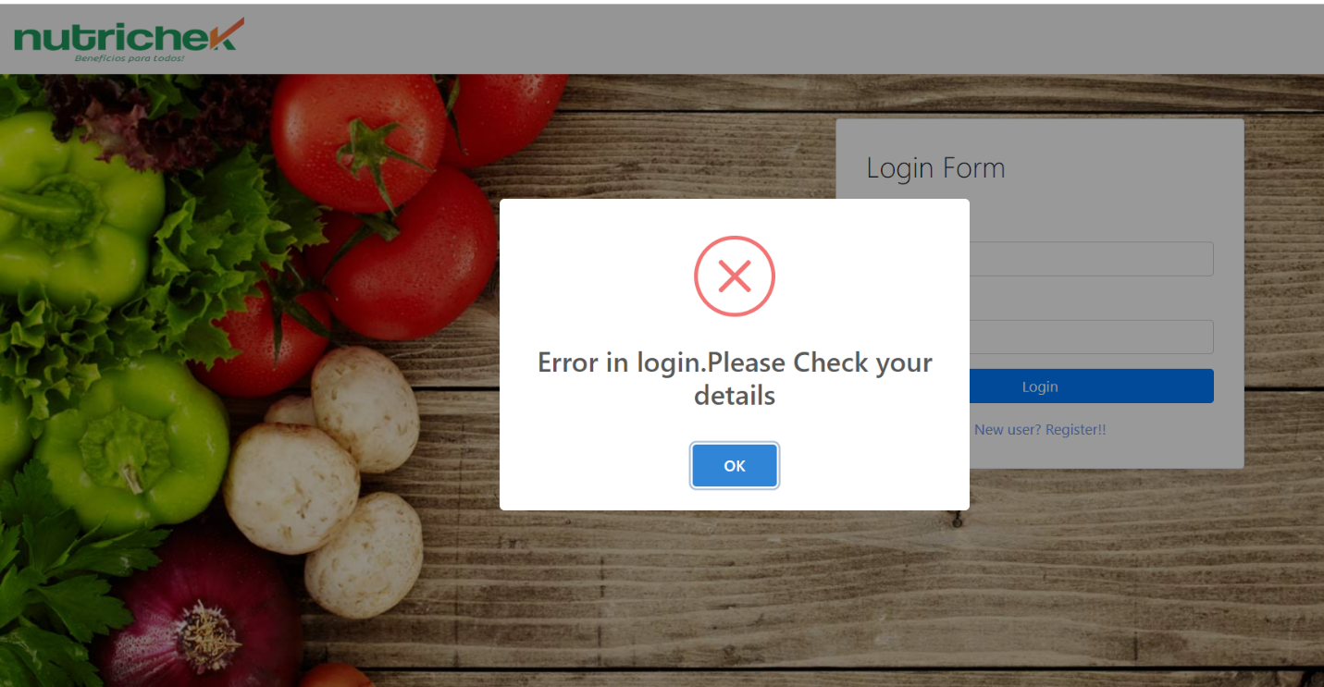

1. User can view the searched item nutrition data like calories, weight in grams.

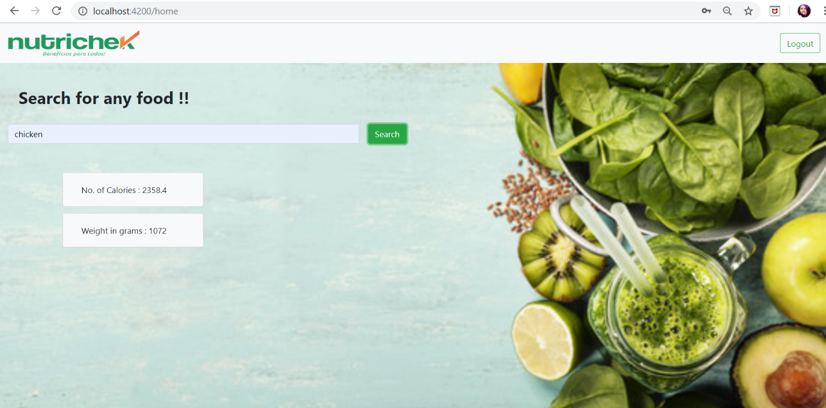

1. User can logout once the search is completed.

**References:**

* <https://www.w3schools.com/>
* <https://developer.nutritionix.com/login>
* <https://responsivevoice.org>
* <https://sweetalert2.github.io/#examples>
* <https://angular.io/guide/form-validation>
* <https://getbootstrap.com/docs/4.0/getting-started/introduction/>

**Conclusion:**

* Got an idea about routing in angular, local storage concepts.